Window Based Application (Swing)

The Abstract Window Toolkit is a portable GUI library.
AWT provides the connection between your application and the native GUI.
AWT provides a high-level abstraction since it hides you from the underlying details of the GUI your program will be running on.
AWT components depend on native code counterparts (called peers) to handle their functionality. Thus, these components are often called heavyweight components.

Swing implements GUI components that build on AWT technology.
Swing is implemented entirely in Java.
Swing components do not depend on peers to handle their functionality. Thus, these components are often called lightweight components.

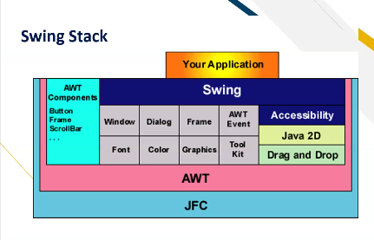

AWT

Pros
Speed: native components speed performance.
Look and feel: AWT components more closely reflect the look and feel of the OS they run on.
Cons
Portability: use of native peers creates platform specific limitations.
Features: AWT supports only the lowest common denominator—e.g. no tool tips or icons.

Swing

Pros
Portability: Pure Java implementation.
Features: Not limited by native components.
Look and Feel: Pluggable look and feel. Components automatically have the look and feel of the OS their running on.
Cons
Performance: Swing components handle their own painting (instead of using APIs like DirectX on Windows).
Look and Feel: May look slightly different than native components.

Every event handler requires three pieces of code:
declaration of the event handler class that implements a listener interface or extends a class that implements a listener interface
public class MyClass implements ActionListener {
registration of an instance of the event handler class as a listener
someComponent.addActionListener(instanceOfMyClass);
3. providing code that implements the methods in the listener interface in the event handler class
public void actionPerformed(ActionEvent e) { ...//code that reacts to the action...
}

public class SwingApplication extends JFrame {
private static String labelPrefix = "Number of button clicks: ";
private int numClicks = 0;
JLabel label = new JLabel(labelPrefix + "0 ");
public SwingApplication(String title) {
super(title);
JButton button = new JButton("I'm a Swing button!");
button.addActionListener(new ActionListener() {
public void actionPerformed(ActionEvent e) {
label.setText(labelPrefix + ++numClicks);
}
});
JPanel panel = new JPanel();
panel.add(button);
panel.add(label);
getContentPane().add(panel);
pack();
setVisible(true);
}
public static void main(String[] args) {
new SwingApplication("SwingApplication"); }}

Sockets
Socket is a logical number comprising of the IP address(System identification) and the port number.
A port number is a logical number assigned to a process. It helps to identify a process on a given system.
Port numbers upto 1024 are reserved ports or also called as well-known ports.

for example
21 – FTP
23 – Telnet
25 – SMTP
80 – HTTP
109 – POP

Java makes network programming easier by encapsulating connection functionality in socket classes.
socket related classes are grouped together in java.net package.

sockets are bi-directional
sockets are reliable
sockets are persistent
socket establishes point-to-point communication
sockets are stream-based connections.

